UKO WAKWIRINDA CORONA-VIRUS

GUKARABA INTOKI
Gukaraba intoki buri gihe ukoresheje isabuni n’amazi meza nibura mu gihe cy’amasegonda 20 cyangwa arukoro yagenewe gusukura intoki

kwirinda kuramukanya abantu bahana ibiganza
Kwirinda kuramukanya abantu bahana ibiganza cyangwa bahoberana

Gukorora Cyangwa Kwitsamura Mu Ruhame
Igihe cyose ukoroye cyangwa witsamuye pfuka ku munwa no ku mazuru ukoresheje ikizigira cyangwa agatambaro gafite isuku kandi uhite ugata ahabugenewe kandi ako kanya uhite ukaraba intoki ako kanya.
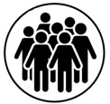

Kwirinda Kwegera Abantu
Irinde kwegera abandi igihe warwaye inkorora, witsamura kandi ukaba unafite umuriro, niba urwaye guma mu rugo
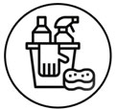

Gusukura Aho Utuye N’aho Ukorera
Sukura aho utuye n’aho ukorera ndetse uhatere umuti wica udukoko

INSHAMAKE KURI CORONAVIRUS
Coronaviruses (CoV) are a large family of viruses that cause illness ranging from the common cold to more severe diseases such as Middle East Respiratory Syndrome (MERS-CoV) and Severe Acute Respiratory Syndrome (SARS-CoV). On 7 January, a new strain that has not been previously identified in humans was discovered in China, known as coronavirus, which encompasses a family of viruses such as the common cold, SARS, and MER. The virus was originally reported from a seafood and animal market in Wuhan City, Hubei Province of China. The new virus was named 2019-nCoV, novel coronavirus.
Coronaviruses are zoonotic, meaning they are transmitted between animals and people, and common species include camels, cattle, cats, and bats. Detailed investigations, however, found that animal coronaviruses can infect people and spread between people, as in the case of MERS-CoV and SARS-CoV.
On 30 January 2020, the World Health Organization, declared the novel coronavirus a Public Health Emergency of International Concern. On 11 February 2020, the World Health Organization renamed the virus COVID-2019.
COVID-19 is mainly transmitted through contact with respiratory droplets from the nose or mouth and can spread from person-to-person when a person with COVID-19 coughs or exhales. Droplets may land on objects or surfaces around an infected person and others may catch COVID-19 when touching objects or surfaces, followed by touching their eyes, nose or mouth.
It is important to keep 1 meter away from a person who is sick because people may catch COVID-19 by breathing in droplets when an infected person coughs or exhales droplets.
The most common symptoms of COVID-19 include fever, cough, and tiredness. Associated symptoms may include aches and pains, sneezing/runny nose, and sore throat. It is possible to become infected without developing symptoms. Older adults and those with underlying medical conditions including cardiovascular disease, diabetes, and high blood pressure are more likely to develop severe illness.
Cases of coronavirus have been confirmed on six continents. To date, there are no single suspected or confirmed cases in Rwanda. Rwanda continues to work closely with the World Health Organization to implement necessary preparedness activities and to continue strengthening surveillance measures.
To prevent the spread of the virus, keep the following tips in mind:
- WASH HANDS: With soap and water for at least 20 seconds or an alcohol-based hand sanitizer and dry with a clean towel or air dry.
- AVOID CONTACT: It is important to maintain at least 1-meter distance from anyone showing signs and symptoms. If you are sick, stay home from work and avoid contact with others.
- WHEN SNEEZING OR COUGHING: Cover mouth and nose with flexed elbow or tissue. Throw tissue away and immediately wash hands.
DUSOBANUKIRWE CORONAVIRUS(https://rbc.gov.rw/index.php?id=708)
COVID-19 is mainly transmitted through contact with respiratory droplets from the nose or mouth and can spread from person-to-person when a person with COVID-19 coughs or exhales. Droplets may land on objects or surfaces around an infected person and others may catch COVID-19 when touching objects or surfaces, followed by touching their eyes, nose or mouth.
It is possible for the virus to spread before exhibiting symptoms, however people are most contagious when they are symptomatic.
- SIGNS AND SYMPTOMS
The symptoms and complications of confirmed COVID-19 cases have ranged from mild sickness to severely ill and dying. Symptoms may include:
- Fever
- Cough
- Shortness of breath
- Associated symptoms may include sore throat, runny nose, body aches, or chills
Based on symptoms associated with similar family viruses, like MERS-CoV, it is believed that symptoms of COVID-19 may occur as quickly as 2 days up to 14 days after exposure.
In addition, if you have traveled to a country with confirmed cases and showing signs and symptoms, notify a healthcare professional immediately or call 114.

What to do if you are sick and how do you prevent the spread?
- Protection measures for those who have recently visited, past 14 days, areas where COVID-19 is confirmed and spreading
- Self-quarantine at home if you are not feeling well. Even if experiencing mild symptoms such as low grade fever (37.3 C or higher), slight runny nose, or headache it is best to stay home until you recover
- If you develop more severe symptoms including fever, cough, or difficulty breathing, seek medication attention immediately. It is important to disclose any recent travel or contact with travelers

How to prevent the spread of COVID-19
If you are sick with COVID-19 or suspect to have symptoms of COVID-19, follow the steps below to prevent the spread in your home and community.
- If you are experiencing symptoms, immediately seek medical attention and notify a healthcare professional about your recent travel
- Do not go out in public, i.e. work, school, public markets, church and avoid all public transportation
- Do not travel if you are experiencing symptoms. Stay home except to seek medical attention
- If you are experiencing symptoms and live with others in your home, separate yourself to another room and if possible, utilize a separate bathroom
- Avoid sharing household items such as dishes, drinking glasses, cups, eating utensils, towels, bedding, or other items with other people in your home. After using these items, you should wash them thoroughly with soap and water
- If you have a facemask available, wear it while in the same room with other people and when you visit a healthcare provider
- When coughing or sneezing, cover your mouth and nose with a tissue, sleeve, or flexed elbow. Immediately throw away used tissues and wash your hands with soap and clean water for at least 20 seconds. If soap and water is not available, use a hand sanitizer that contains at least 60% alcohol Avoid contact with pets or other animals while sick
- Immediately seek medical attention if your symptoms are getting worse, i.e. if you are having trouble breathing. Call our toll-free number 114 or inform your community health worker or nearest health facility ahead of time
Prevention steps for close contacts with an infected person
If you believe you have had close contact with someone who has confirmed COVID-19 or someone who is being evaluated for COVID-19, the following precautions should be taken:
- It is important that you closely monitor your health status beginning from day one that you had contact with an infected person, up to 14 days of last contact with the person
- Closely monitor for signs and symptoms including:
  - Fever
  - Cough
  - Shortness of breath
  - Associated symptoms may include sore throat, runny nose, body aches, or chills
- If you develop any of these symptoms, seek medical attention immediately
  - Call our toll free number 114 or inform your community health worker or nearest the health facility and notify them that you have had close contact with someone who is confirmed to have, or currently being evaluated for COVID-19

Who is at risk?
Anyone who lives in affected areas or who has been in contact with travelers from affected areas is at risk. However, older people and people of all ages with severe underlying health conditions including cardiovascular disease, lung disease, and diabetes, and cancer are at higher risk. For those at higher risk for COVID-19, it is important to take actions to reduce your risk of getting sick.
- Take precautions to keep space between yourself and others
- In public, keep away from others who are sick and wash hands frequently
- Avoid crowds or large gathering
- Avoid non-essential travel
- Stay home as much as possible to reduce your risk
Diagnostic testing is currently being conducted in public health laboratories with a test kit.
If you develop symptoms including fever, cough, and/or difficulty breathing, and have been in close contact with a person known to have COVID-19 or have recently traveled to an area with ongoing spread, stay home and contact your nearest health facility or call our toll-free number 114. A healthcare professional will determine if you have signs and symptoms COVID-10 and whether you should be tested.

There is no vaccine and no medicine currently available to prevent or treat COVID-19. Those affected are treated with supportive care to relieve symptoms.
If you are experiencing any signs and symptoms, seek medical attention immediately.
Content sources: CDC Centers for Disease Control and Prevention, WHO World Health Organization, March 2020

Information for Healthcare Providers(https://rbc.gov.rw/index.php?id=711)
The following information is to help healthcare professionals across the sector to identify signs and symptoms of COVID-19 infection. This is particularly important at screening sites, i.e. airports, for those who have traveled to affected areas.
While there is no specific treatment for the infection, immediate supportive care and medical treatment is imperative to persons under investigation.
Healthcare professionals must obtain a detailed travel history for all patients presenting with symptoms of fever, coughing, and/or shortness of breath. The clinical presentation of COVID-19 can range from non-specific signs and symptoms of acute respiratory illness to severe pneumonia and respiratory failure.
Familiarize yourself with the signs and symptoms to serve as a guideline for evaluation. Patients should be evaluated based on clinical presentation, as well as travel history. It is believed that symptoms of COVID-19 may occur as quickly as 2 days up to 14 days after exposure.
It is important for healthcare professionals to immediately implement infection prevention and control measures if a patient is suspected of having COVID-19.
For more information visit CDC Centers for Disease Control and Prevention for a healthcare professionals preparedness checklist: www.cdc.gov/coronavirus/2019-ncov/hcp/hcp-personnel-checklist.html

How to protect yourself from getting sick(https://rbc.gov.rw/index.php?id=719)

Travel Safety

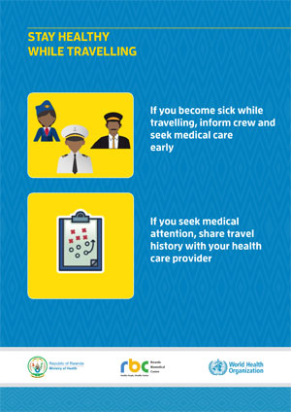
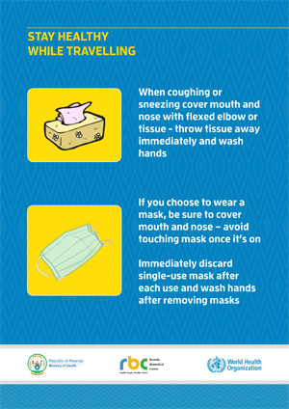
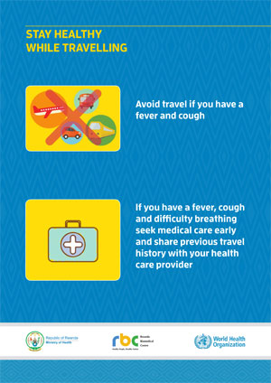

Food Safety
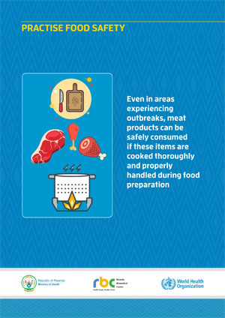
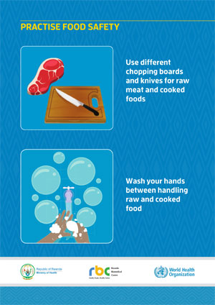
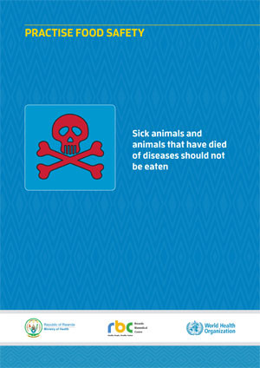

Market Safety
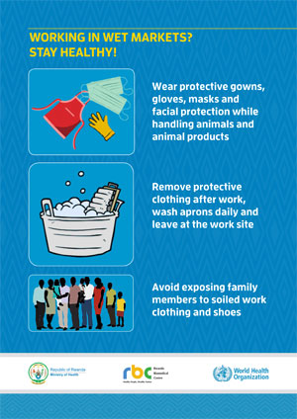
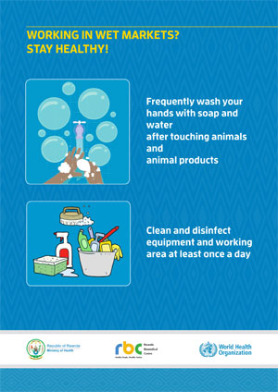

*Materials adapted with authorization from the WHO World Health Organization

